SUBJECT | SPRING 1  School Theme: | SPRING 2  Out of this World
LITERACY  In addition to the themes covered here  Literacy will also include teaching of grammar rules, spelling strategies and punctuation, along with reading and comprehension skills.    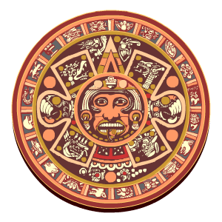 | Narrative Poetry - We will be using the mythical island of Hy-Brasil to inspire some poetry writing – focusing on simile and metaphor and investigating the use of the subjunctive voice.  Diary Writing – We will develop our  recount skills by way of writing a diary from the perspective of a child from the Brazilian favelas.  Gothic Narrative Writing –  We will learn about the elements of gothic stories telling, using our previous class novel, Clockwork, to investigate what makes a successful gothic story.  Spelling, Punctuation and Grammar -  As spelling, punctuation and grammar is now an important element of the curriculum, and is also tested during SATs in summer, we will be looking at new grammar rules (year 5) and revising our grammar skills (year 6). We will also, of course, focus on the real reason we are studying English grammar – to be successful, engaging and competent writers. | Non-Chronological Report  We will learn about the ancient Mayans and write a non-fiction information booklet about aspects of life and beliefs of the Mayans and their demise.  Spelling:  We will continue to focus hard on improving our spelling ability, using patterns and rules, along with using our knowledge of the root word as a method to increase our competence in spelling unfamiliar words.  Our Class novels will be ‘Kasper, Prince of Cats’ by Michael Morpurgo, and ‘The Time Machine’ by H.G. Wells.
NUMERACY  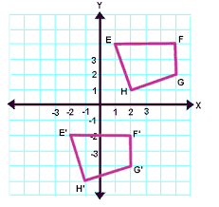 | Maths planning based around the White Rose Maths Mastery Plan for mixed years groups, along with regular explicit arithmetic and times table practice.  Number - Fractions  Number - Decimals  Number - Percentages  Number - Multiplication and Division  Number – Algebra and Ratio  Opportunities to apply mathematics to other subjects  Science – Statistics , analyzing data – growing beans  Statistics reading and interpreting data.- weather measurements  MOCK SATs Week will give Children prior experience of what is to be expected in May using last year’s tests

HISTORY/  GEOGRAPHY | We will complete our investigation of the country of Brazil by looking at the life of children brought up in the favelas of Rio and how their lives differ from those of children in the UK. | The study of a non-European society that provides contrasts with British history – The Mayan civilization c. AD 900  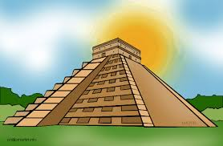
RE | Christianity  Standing up for Your Beliefs  Communion and Easter
SCIENCE  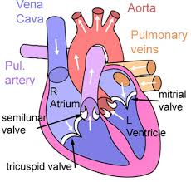 | The Human Circulatory System –  We will :  1, Identify and name the main parts of the human circulatory system, and describe the functions of the heart, blood vessels and blood  2, Describe the ways in which nutrients and water are transported within animals, including humans.  3, Learn about the relationship between diet, exercise, drugs, lifestyle and health. | Properties and Changes in Materials  We will: compare and group together everyday materials on the basis of their properties,  Learn that some materials will dissolve in liquid to form a solution, and describe how to recover a substance from a solution, learn how mixtures might be separated, including through filtering, sieving and evaporating, give reasons, based on evidence from comparative and fair tests, for the particular uses of everyday materials, including metals, wood and plastic and demonstrate that dissolving, mixing and changes of state are reversible changes  
Art and Design  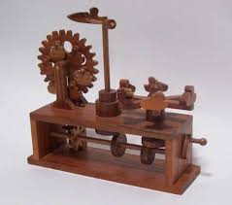 | Cams and Mechanisms  We will be building our own Victorian Time Machine mechanisms using cams, levers and pulleys to create a moving mechanical inventions, and inspired by our class novel, The Time Machine by H.G.Wells. | ‘Ancient Structures and Building Design – The Mayan Pyramid  We will investigate the ideas used by the ancient builders, including the Egyptians and Mayan pyramid builders, building our own scale designs.
MUSIC   | We will take a look at classical music after the half term break, using the Planets Suite to introduce ourselves to this genre.  We will have the opportunity to take part in the CASMA concert again this year – with the theme of South Asian fusion. The group will rehearse the songs and choral arrangements for the joint school concert to be held in Norwich in February.
MFL  French   | We will be following the Rigola French scheme, continuing to improve our conversational French. This terms topic is Ma Journee – asking and talking about daily routines.
PE  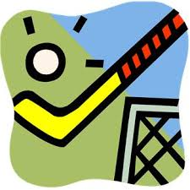 | In the first half of this term, we will be building our indoor athletics and circuit skills, and begin to develop quick sticks hockey skills.  Children will have the opportunity to take part in inter and intra- school competition in tag rugby, hockey, basketball, girls and boys football and indoor athletics this term, with everyone having the opportunity to compete in at least one inter school competition. In addition, a group of children will be competing in the South Norfolk Tag-Rugby finals, the girls County Football Final and hopefully the South Norfolk Athletics finals.  In addition, we will be receiving specialist Zumba dance/fitness teaching on Wednesday afternoons in the first part of the term.
PSHE  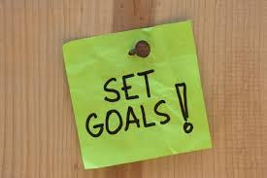 | Personal, Social and Health Education  Going For Goals  We will use our class discussion and circle time to focus on the things we need to think about in order to set achievable targets for ourselves – discussing ways to accept both success and disappointment.  Good To Be Me  We will use our class discussion and circle time to focus on the things we should celebrate about ourselves, boost our self-esteem, and recognize our talents and abilities.  Through the term, the year 6 children will be using their Peer Mediating training to help other children in the school with any playground/lunchtime/breaktime issues.
ICT  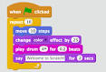 | Designing Apps:  We will be designing our own programs using methodical, clear planning and pictorial methods.
Homework  Schedule Reminder | Homework and Expectations:  Homework will be handed out on Fridays – we will always discuss and look at the expectations when it is handed out. Children will be asked to update their diary to reflect this.  Wednesday – Literacy/Maths due in.  It is essential homework in on time as Wednesday lessons may include detailed marking and walkthroughs.  Thursday – Spelling test – Spellings should be written across 2 pages in the homework spelling book and be in school on Thursday for checking. Children will be required to retest the following day if their result does not meet the required level.

